Rodrigo Brasil 11/2023

### **Part 1: Staging Windows 10**

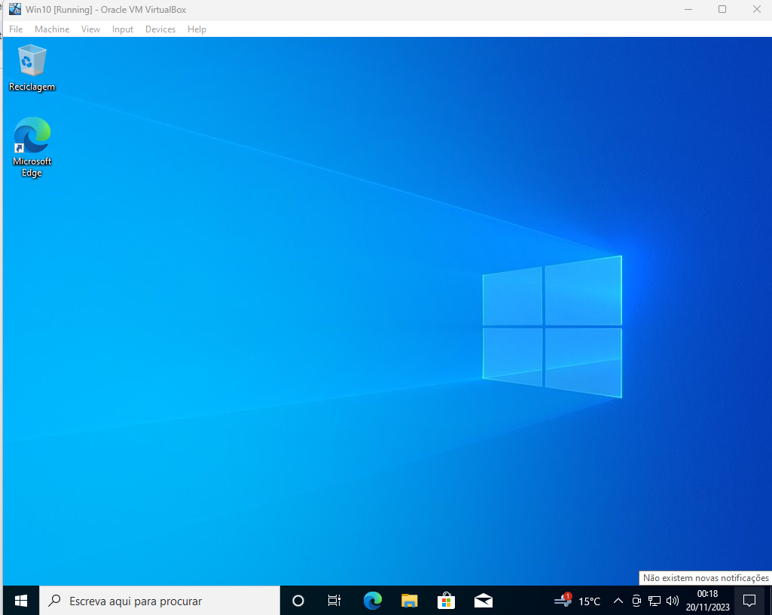

Windows 10 VM deployed

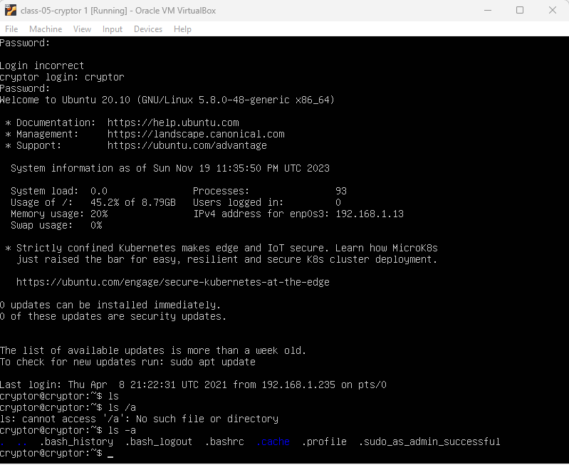

Cryptor (Ubuntu Server) VM deployed



using the command ip -a it gives the machine IP



on the windows 10 vm using the command line and using the ssh command

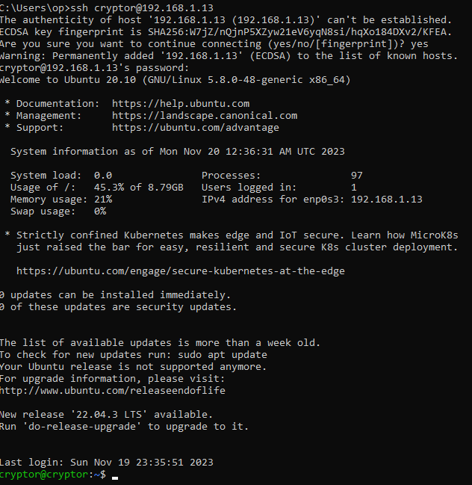

successfully connected to the cryptor vm

### **Part 2: Data Encryption with 7-Zip in Windows**

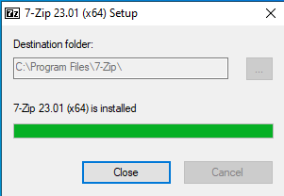

Install 7-zip by downloading it from [7-zip.org](https://7-zip.org/a/7z2301-x64.exe)